Waypoint Collection Using DQN

Department of Aeronautical and Aviation Engineering
The Hong Kong Polytechnic University

Student 1 Name: Wang Yuteng
Student 1 ID: 21098995D
Student 2 Name: Chow Chee Sum
Student 2 ID: 25025107d
Date:2026/04/14 (Tuesday)

Contents
Project Overview 3
Methodology 3
Result 5
Conclusion 5
Future work 6
References 6

Project Overview
This project aims to demonstrate our team’s effort to make progress in solving object tracking by utilizing a deep reinforcement learning algorithm named Deep Q-Network (DQN). Born amid the rise of deep learning, DQN is an algorithm widely known for mastering Atari games once thought impossible [1].
The algorithm consists of a neural network known as Q-network that accepts states as input and outputs the quality of all possible actions taken (known as Q-value). DQN was built on the foundation of Q-learning, where the quality of each action in each state was stored in a look-up table rather than a neural network [2]. The Q in Q-learning and DQN stands for quality, and compared to Q-learning, DQN allows for continuous state space and compresses information by approximating batches of discrete state points with functions that have less parameters, thereby reducing the memory.
When training DQN, if the reward function is properly set up and the training parameters are well-tuned, the quality of best action will become increasingly aligned with achieving the highest cumulative reward, thereby achieving what the trainer wants, while the quality of bad actions will continue to be lowered and these actions will not be taken.
The grand goal for this project is to train a DQN that enables the agent to find the waypoint regardless of the initial position of the agent or the waypoint. The agent (be it a drone or similar UAV) will be randomly placed and can move freely within a rectangular boundary. There will be only one waypoint during training, and its position will also be randomly initialized. The agent should reach the waypoint within a certain radius while not exceeding the time and speed limit or crossing the boundary. When that happens, the agent will have “found the waypoint.”

Methodology
The simulation confines the agent in a rectangular boundary. Where each training episode features a single fixed waypoint. The agent must reach the waypoint within a predefined radius without exceeding the maximum allowable time, violating speed limits, or crossing the boundary.
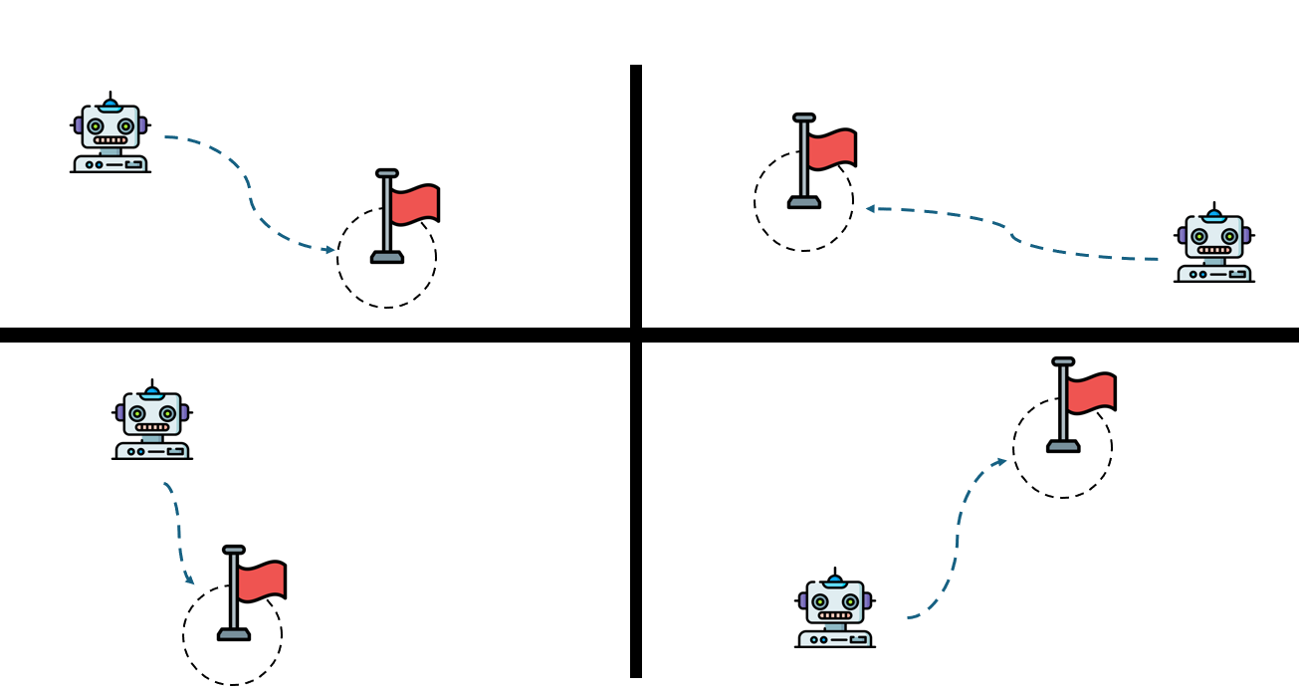
The environment state at any time step is represented by the vector:
$$s=\left[x, y, v_{x}, v_{y}, w_{x}, w_{y}\right]$$
where $x,y$ are the global coordinates of the agent, $v_{x},v_{y}$ are the velocity components of the agent and $w_{x},w_{y}$ are the distance between the agent’s current position and the waypoint.
The action space is represented as follows:
$$a=\left[a_{x},a_{y}\right]$$
Each acceleration component accepts 11 equally spaced discrete values, yielding a total of 121 different action combinations.
Training employs the Huber loss function, which is quadratic for small errors, but linear for large errors, thereby providing greater robustness to statistical outliers.
$$Huber=\left\{\begin{aligned}\frac{1}{2}{\left(y-\hat{y} \right)}^{2}, &for \left|y-\hat{y}\right|≤δ \\ δ\left(\left|y-\hat{y}\right|-\frac{1}{2}δ\right), &otherwise\end{aligned}\right.$$
Exploration-exploitation trade-off is controlled by an $ϵ$-greedy policy in which the exploration probability $ϵ$ decays exponentially with each training episode, encouraging broad exploration in early episodes and exploitation of the learned policy in later stages.
The discount factor is set to $γ=0.99$ to place emphasis on long-term cumulative reward. The neural network uses ReLU activation functions throughout and parameters are optimized with the Adam algorithm, to flexibly adjust learning rate based on gradient statistics.
The code is implemented through two Python modules. The file main.py implements the complete DQN algorithm and training loop using the PyTorch framework. The companion module Environment.py contains simulation dynamics and reward function.
At conclusion of each episode, triggered by either reaching the waypoint or violating any rule, the environment resets. Both the initial position of the agent and the waypoint are randomly re-initialized, enabling DQN to learn a generalizable navigation policy across the full range of possible initial conditions.

Result
Four separate training runs were conducted using a 4-layer multilayer perceptron (MLP) with 128 units per hidden layer. In each case, the cumulative reward per episode was plotted against the episode number.
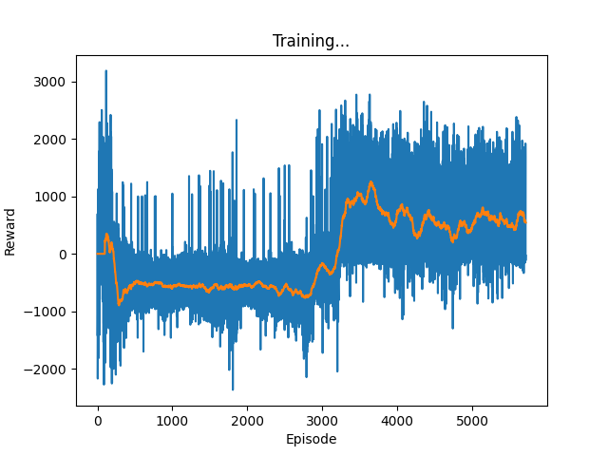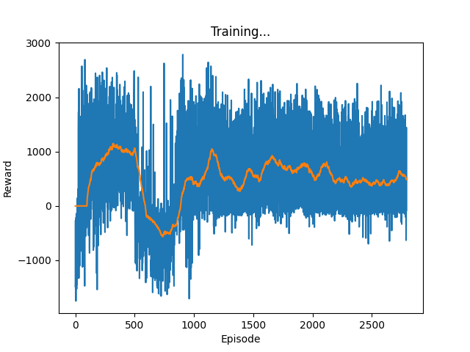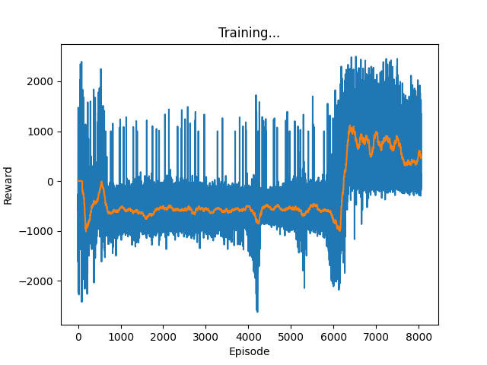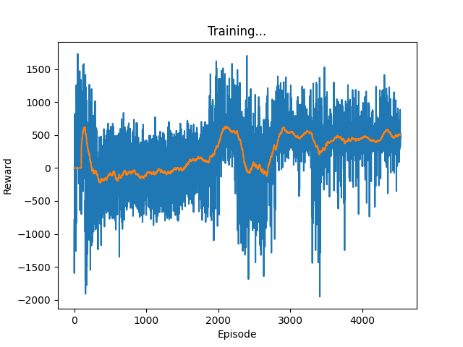

Conclusion
This project applied reinforcement learning techniques to the problem of waypoint collection and target chasing using DQN. Over the course of development, the team gained a comprehensive understanding of DQN principles and implementation and constructed a functional training environment.
However, the overall progress remained limited as the goal proved far more ambitious than initially anticipated, primarily due to the extensive fine tuning and long training times required. While the obtained results are interesting, they lack compelling visual demonstrations, such as rendering videos of the agent chasing waypoints. Furthermore, the interpretation of the current performance metrics still have considerable room for investigation.

Future work
In the short term, efforts will focus on continuing to improve and fine-tune the current model to achieve more stable reward growth across the training process. Additionally, a simple video rendering module will be developed to translate the model into animated visualizations, allowing for better understanding of the agent’s behavior.
In the long term, the framework will be expanded to support more complex scenarios involving multiple waypoints and dynamically moving targets, thereby increasing the realism of the navigation task. Comparative experiments with other reinforcement learning algorithms will also be conducted to systematically evaluate their respective strengths and weaknesses in this task.

References
[1] V. Mnih, K. Kavukcuoglu, D. Silver, A. Graves, I. Antonoglou, D. Wierstra, and M. Riedmiller, “Playing Atari with deep reinforcement learning,” arXiv preprint arXiv:1312.5602, 2013.
[2] C. J. C. H. Watkins and P. Dayan, "Q-learning," Machine Learning, vol. 8, no. 3, pp. 279–292, May 1992.
There are no sources in the current document.

